Nama : Asri Nihal Salsabila

NIM : 18090087

Kelas : 5C

1. URL : http://localhost/ci_fauzi/index.php/MatakuliahValidation
2. Source Code

* application 🡪 controllers 🡪 MataKuliahValidation.php

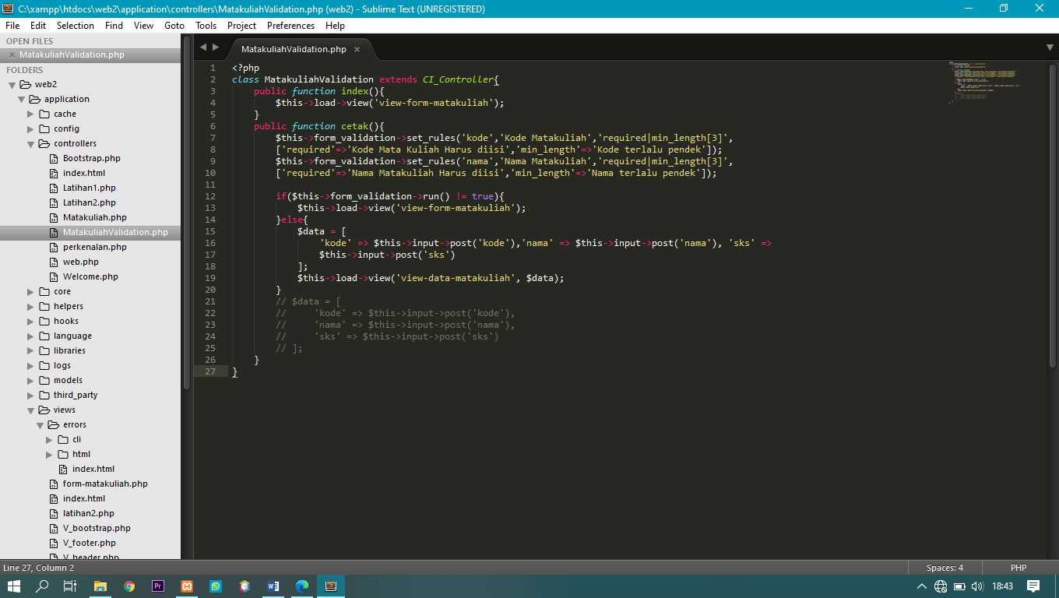

* application 🡪 views 🡪 form-matakuliah.php

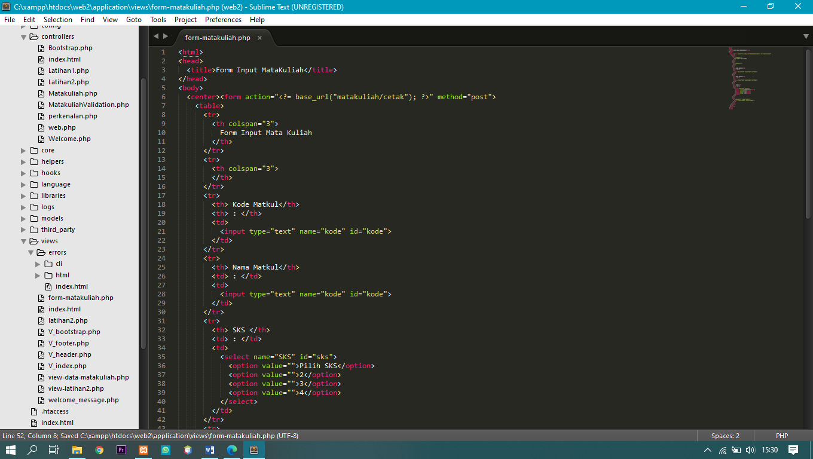

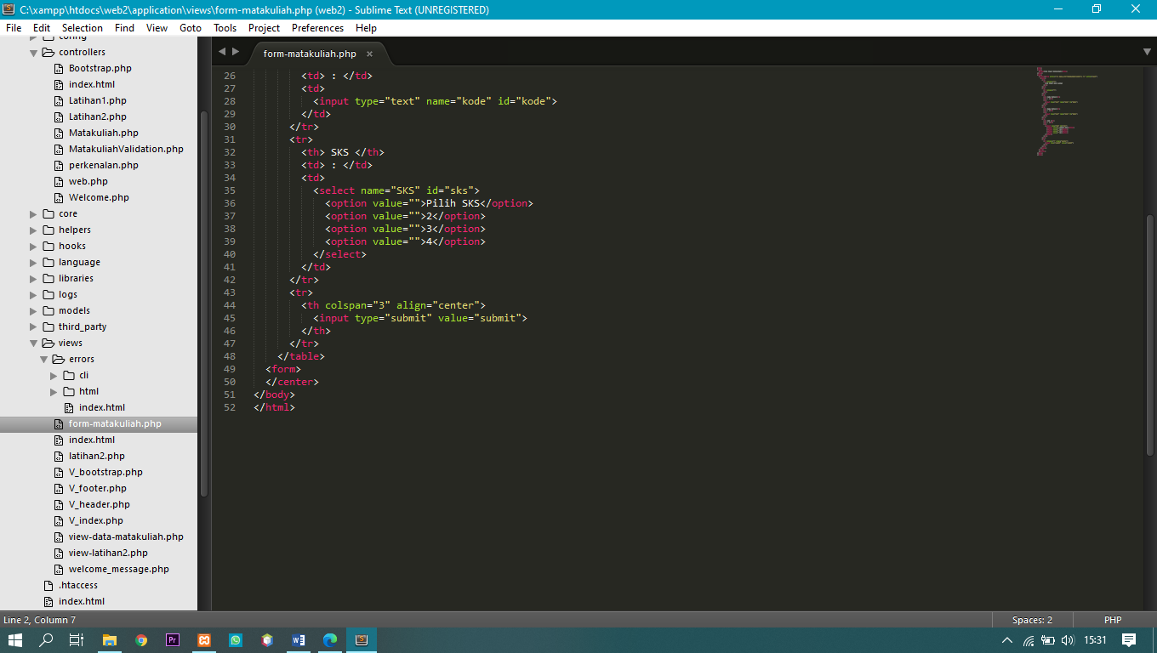

1. Screen Shoot

